ACAO Board of Directors Meeting Minutes
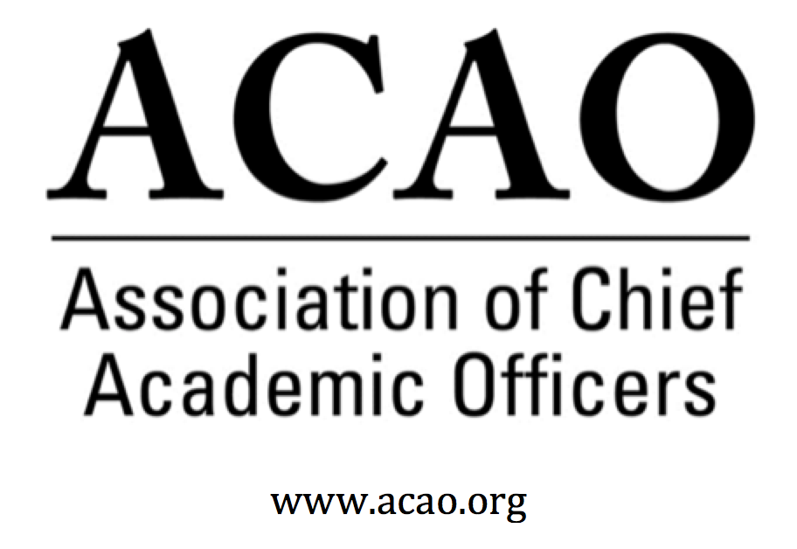

May 6, 2020: https://zoom.us/j/707742741, 2-3 PM (Eastern)

Name | Attend | Name | Attend | Invited Guests | Attend
Mary Boyd | Y | Pam Stinson | Y | Junius Gonzales | N
Gail Baker | Y | Greg Ochoa | Y | John McCarthy | N
Kathy Johnson | Y | Peter Nwosu | Y | Michael Quillen | Y
Beth Ingram | Y | Patricia Salkin | Y | April Mason/Adv /Cl | Y
Scott Newman | Y | Andrew Shean | Y
Laura de Abruna | Y | Constance St Germain | Y
Michael Evans | Y | Lori Werth | Y
Connie Johnson | Y | Laura Woodworth-Ney | N
David Manderscheid | Y | Sharon Vasquez/Adv Cl | Y | Doreen Murner | Y

- Review and approval of April Board Meeting minutes April Minutes M. Boyd - Call for discussion/updates.
  - No updates/discussion. Motion moved to approve minutes. All in favor. Motion Passes

- Board transitions and current positions: Secretary, Open. Welcome Michael Quillen
  - M Boyd welcomed Michael Quillen.
  - S. Vasquez noted she will transition off the Advisory Council. April Mason will take the chair position. S. Vasquez introduced April to the board. April was a founding member of ACAO & one of its first presidents.

- Bylaw changes – Board to recommend changes to the membership. Proposed Bylaw Changes. Quorum is 2/3 of membership who cast ballots. K. Johnson
  - Bylaws change requires 2/3rds vote to approve of those members in good standing who have cast ballots.

- ACAO Member virtual Business Meeting – Association update on financials, membership & vote on bylaws, certify elections. Potential dates: June 17th, June 24th or July 14th; 1pm ET
  - D Murner will send a doodle poll for potential consensus of above mentioned dates

- ACAO March Financials & 2020 Budget – B. Ingram
  - Finance Cmte recommended budget to the board. Motion moved to approve 2020 budget. All in favor – motion passes.

  - L de Abruna discussed Professional Fees line item. M Boyd & B Ingram will connect with AMC Source.

- Committee Updates

  - Digital Learning Cmte – L. de Abruna – Discussion of proposed name change
    - L de Abruna would like ACAO to help distribute a survey from Tyton Partners who are part of the Every Learner Everywhere initiative. They have a high level of respect in higher education. Tyton would like ACAO to send the survey to our members. Institutions that participate will receive a report. Tyton will supply language for the survey intro.
    - Minor discussion: DLC committee will retain its current name: Digital Learning Committee

  - Professional Development – S. Newman – Future townhalls
  - S Newman discussed provost to provost virtual session/conversations. All agreed was needed. First two topics are i. and ii. Dates to be determined. A Mason will take the concept to the Council
    - How to do effective budget reductions (including furloughs)
Rename to “budget uncertainties”. Townhall collaborators: B Ingram, P. Nwosu, K. Johnson
    - What will our fall semester look like?
Townhall collaborators: L de Abruna, D. Manderscheid, P. Salkin
    - Debrief after the semester – what worked, what to fix
    - Moving faculty: remote to online, incentivize over the summer
    - The student experience
    - Incoming students
    - Graduating students <--Probably less pressing now!
    - Working with shared governance representatives/unions
    - Accreditation-related issues
    - Getting healthcare students prepared for clinical experiences (e.g., physicals, immunizations, fitted PPE, advanced life-saving certs., etc.)

  - Innovation & Strategies – L. Werth – Have not met yet.
  - Membership – G. Ochoa –
    - Poll members on townhall topics via the listserv

- September/October virtual Board Meeting – to replace our face to face meeting.
  - Group reached consensus that a longer meeting may not be necessary.

- Partnerships: PAHENA (Provost and Academic Affairs Assistants in Higher Education National Association) (K. Johnson). Proposed Partnership with ACAO
  - PAHENA has decided to wait until COVID-19 times of challenge settle down. Discussion will resume in the future.
  - Discussion of becoming the “fiscal agent” for PAHENA. There was consensus that ACAO should NOT be the “fiscal agent” but perhaps open a new category of membership for PAHENA instead.

- ACE update. (K. Johnson and M. Boyd)

  - M. Boyd & K. Johnson talking with ACE May 7. Update next board meeting.
  - Blog series is going strong. K. Johnson asked for interest on a COVID-19 “reflections” for the blog which would get published sooner considering that is of primary focus.

- Our next regularly scheduled board meeting is June 3rd @ 2pm ET.

2020 Board of Directors: Assigned Roles
Executive Committee | Director | Role/Committee | Institution | Term Ending
 | Mary Boyd | President | Berry College | 2020/2022
 | Kathy Johnson | Past President Responsibility: Chair of Nominating and  Bylaws Committees | IUPUI | 2020/2021
 | Gail Baker | President Elect  Editorial Team | University of San Diego | 2022
 | Beth Ingram | Treasurer | Northern Illinois University | 2021
 | TBD | Secretary
 | Doreen Murner | Executive Director | AMC Source | n/a
 | Laura Niesen de Abruna | PI: Digital Fellows Project  Finance Committee  Editorial Team  Digital Learning Cmte-Chair  Innovation & Strategies | York College of Pennsylvania | 2021
 | Gregory Ochoa | Chair: Membership & Communications  Digital Learning Committee | Potomac State College of West Virginia University | 2021
 | Peter Nwosu | Membership & Communications  Innovation & Strategies  Digital Learning Committee | Lehman College of CUNY | 2021
 | Connie Johnson | Professional Development  Editorial Team  Digital Learning Committee | Colorado Technical University | 2022
 | Andrew Shean | Innovation & Strategies  Digital Learning Committee | National University System | 2022
 | Lori Werth | Professional Development  Innovation & Strategies | University of Pikeville | 2022
 | Laura Woodworth-Ney | Innovation & Strategies | Idaho State University | 2022
 | Michael Quillen | Membership Committee | Rowan-Cabarrus Community College | 2022
 | Michael Evans | Finance Committee | Southern New Hampshire University | 2023
 | David Manderscheid | Finance Committee | University of Tennessee, Knoxville | 2023
 | Scott Newman | Professional Development Committee | Oklahoma State University Institute of Technology | 2023
 | Patricia Salkin | Membership Committee | Touro College | 2023
 | Constance St. Germain | Finance Committee | Capella University | 2023
 | Junius Gonzales | Professional Development | NY Institute of Technology | 2023
 | John McCarthy | Membership Committee | UMass – Amherst | 2023
 | Pam Stinson | Professional Development | Northern Oklahoma College | 2023
 | Sharon Vasquez | Chair: Advisory Council (ex officio) | Provost Emerita, University of Hartford
*Additional Professional Development Committee Member: Ellen Granberg, Provost, Rochester Institute of Technology
*BJ Reed, Innovation & Strategy Committee Member: Ex officio Advisory Council rep
*April Mason, Membership & Communications Committee Member: Ex officio Advisory Council rep

