ACAO Board of Directors Meeting
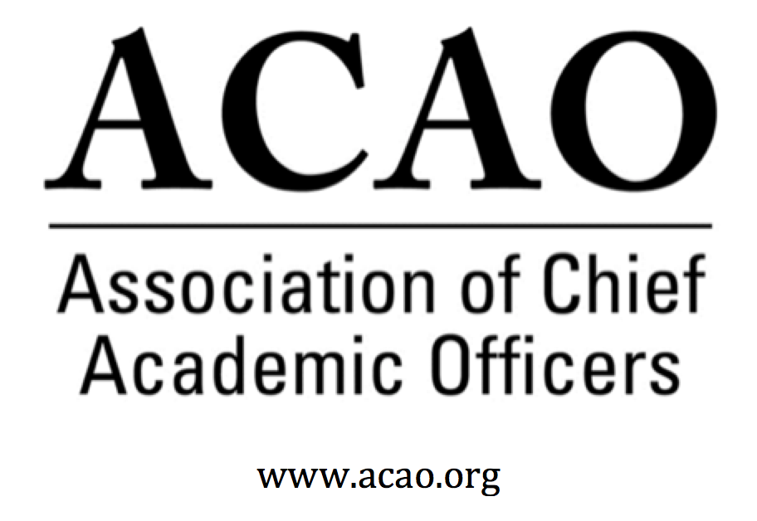

MINUTES

March 9, 2019

Marriott Downtown

Philadelphia, PA

4:00 – 6:00pm / Rooms 402,402

Name | Attend | Name | Attend | Name | Attend
Martha Potvin | Yes | Laura de Abruna | Yes | Michaele Whelan | No
Kathy Johnson | Yes | Peter Nwosu | Yes
Mary Boyd | No | Gregory Ochoa | Yes
Rick Miranda | Yes | Patricia Rogers | Yes
Kevin Carman | No | Connie Johnson | Yes
Charles Cook | No | Todd Diacon | No | Doreen Murner | Yes
Kelli Brown | Yes | BJ Reed | Yes

- Board photo
  - Postponed until July face to face meeting to include newly elected board members

- Feb 06 Board Minutes – Vote to approve – M. Potvin
  - BJ Motioned to approve. Connie second. All in favor. Motion passes.

- ACE Engage Platform demonstration by ACE
  - Philip Rogers & Louis Soares gave an operational & programming update on ACE Engage. Encouraged board to visit live demos while at ACE meeting. Engage platform is meant to be all encompassing for leaders, institutional transformation and student success. Members will be supported in various areas based on what they need; individual mentoring (ACE Fellows), transformation labs (12-18 month long on an issue), student success labs & equity minded leader transformation labs. Most face to face institutes and learning will be focused regionally with “strategy summits”. A series of regionally based meetings. And the platform will have a consolidated learning experience with micro-courses. ACAO was encouraged to participate and add to the micro-courses. Both Philip & Louis asked for suggestions on how ACE and ACAO can work together.

- Membership Committee Update – G. Ochoa
  - Discussions on how to “find” sitting provosts and newly appointed provosts. Suggestions were: Each board director focus on their region on who they know and solicit to become a member. Have an undergrad work through the web to find contacts at institutions by state. Board agreed to add assistant/associate provosts to the membership as a way of creating continuity for the institution when the provost retires/moves on. All agree membership is key to our success.

- Communications Committee Update – C. Johnson
  - Suggestion from last board meeting to combine Membership & Communications Committees.

- Bylaws Committee Update – R. Miranda
Combining Membership & Communications Committees
Rick motioned to combine membership & communications committees. Martha second. All in favor. Motion passes.

- Finance Committee Update - M. Potvin
  - Martha updated board on Mary’s finance report. Board is requesting Mary to complete a $70k budget, smaller than last yr, so the budget is balanced. Revenue/membership is the driver since there are not many expenses to cut.

- Advisory Council Update – C. Johnson/K. Johnson
Propose that a Council Member becomes an Ex-Officio member of the board
There is Council interest to sit on the board in an ex-officio capacity and to include the board member on the Board Listserv. And, for the Council to be on the Members ONLY listserv. Council would like to help with membership. Rick suggested that Council members introduce themselves to new provosts/members as an ACAO mentor. A proactive rather than passive way to engage provosts. Board agreed (Kathy will appoint) Sharon Vasquez would be the ex-officio Council member to the board.

- Digital Fellows Update – L. de Abruna
  - An additional $20k was received for the 5th & final convening of the Digital Fellows program (Philadelphia ACE meeting). Laura hopes regional conferences will continue into the future.

- Strategic Plan Completion – K. Johnson
  - Rick motioned to adopt the final version of the strategic plan. Martha second. All in favor. Motion passes.

- Partnership Opportunities
  - CCAS
  - AASCU
  - CIC
  - Gardner Institute
There is significant interest in working with other associations and groups to increase membership, connect with more provosts and aspiring provosts and to increase ACAO’s presence in the market. Several organizations identified and assigned:
AAC&U – Kathy Johnson
Accrediting Conferences- Pat Rogers
CIC – Laura de Abruna
AASCU – Pat Rogers
NACUBO- Doreen
Gardner Inst – Laura de Abruna
CCAS – Martha Potvin (already made the connection & looking for programming at their Nov conference)
Educause – Pat Rogers

- March Board Meeting & ACAO Business Meeting agenda & planning. April board meeting discussion – K. Johnson
  - Kathy discussed need for a face to face meeting this summer in DC at the ACE HQ. Doreen will investigate July dates & connect with ACE for space.

Meeting adjourned 6pm.

Future Board Meetings
April 3, 2019 2pm ET
May 1, 2019
June 5, 2019
July 3, 2019 (will be cancelled based on July face to face meeting)
August 7, 2019
September 4, 2019
October 2, 2019
November 6, 2019
December 4, 2019

