ACAO Board of Directors Meeting
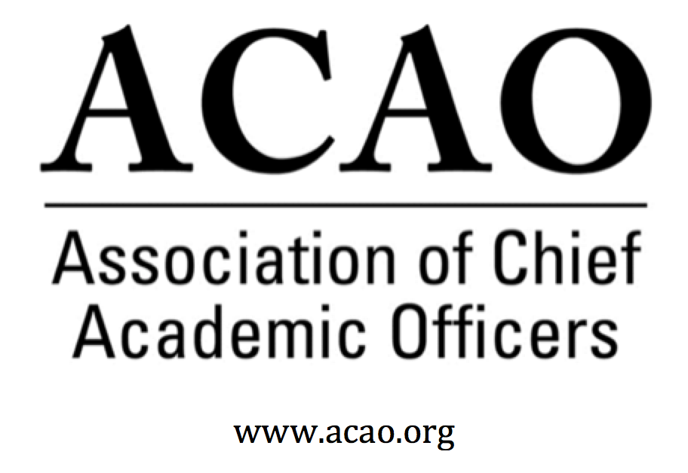

Minutes

October 3, 2018, Conference Call

Name | Attend | Name | Attend | Name | Attend
Martha Potvin | Yes | Laura de Abruna | Yes | Michaele Whelan | No
Kathy Johnson | Yes | Peter Nwosu | Yes
Mary Boyd | Yes | Gregory Ochoa | No
Rick Miranda | No | Patricia Rogers | Yes
Kevin Carman | Yes | Connie Johnson | Yes
Charles Cook | Yes | Todd Diacon | No | Doreen Murner | Yes
Kelli Brown | No | BJ Reed | No

- ACE/ACAO debrief, ACE 9/5 presentation and 9/21 Program Cmte meeting with ACE:
M. Potvin/K. Johnson – Discussion of 9/5 & 9/21 meeting with ACE. All agree ACAO and ACE should work together and ACE seems committed to working with ACAO. Many directors still have questions one of which is, How does ACAO still connect with ACE, except for paying for portal access? Kathy indicated ACE is eager to maintain a partnership with ACAO and is receptive to working together. They acknowledged lapses in the past. Peter Nwosu commented we could be valued partners within the Engage Platform, which could be a new approach to leadership development. We could also participate in their face to face regional meetings. Doreen suggested the MOU language should reference ACAO as a “key partner” working in collaboration with a shared vision and goals and not be considered a “solution provider”. We also may want to consider a “non-compete” clause, especially since ACE is already working with Educause. All agreed CAOs need to be part of the conversation and process, or at least at the table.
Kathy Johnson is working on ACAO programming with ACE for the March meeting.
  - MOU Update – ACE has ideas on restructuring the MOU and will do a first draft. ACAO will critique once comments are received from ACE.
- June 6 Board Minutes – Vote to approve – M. Potvin – Correction: Peter Nwosu was in attendance. Motion to approve minutes with minor correction: Mary Boyd 2nd Peter Nwosu – Passed unanimously
Sept 5 Board Minutes – Vote to approve – M. Potvin -Motion to approve, Mary Boyd, 2nd Laura De Abruna – Passed unanimously
- Strategic Planning document and update: K. Johnson
https://docs.google.com/document/d/1qIs5kmCx8Lybmnd-3MZhYPI1Yax20hQ4o7x3oUgvaEk/edit?usp=sharing

Working on the SP is difficult without the face to face component. Kathy wants to wrap up by January. Most important is to align the committees with the goals & objectives of the plan. Reminder for all directors to look at the plan & comment, especially the committee chairs, looking for alignment with the plan’s goals.

- Potential ACAO programming for the ACE meeting March 2019, Philadelphia – The Master Class will be deferred until the 2020 annual meeting for Digital Fellows. Three ACAO sessions are being planned. Kathy wants board input on potential speakers (she will send notes about the sessions). Kathy will schedule follow-up with ACE on programming. Some suggestions were: President Purdue (Connie) and Dept of Education. We should also be mindful of diversity of speakers and diversity of organizations represented.
- Digital Fellows: Grant extended until Jun 2019. Potential goals for the additional
funding. L. de Abruna – Additional regional convenings have been organized:
Oct 25/26: Austin Community College
February 2019: IUPUI
October: North Carolina System
January 2019: Colorado State University & Colorado Tech
March 2019: at ACE meeting in Philadelphia
- Collaborations and Stakeholder Relationships
  - Conversations with CCAS - M. Potvin – Council of Colleges of Arts & Sciences. Martha indicated they were very open to working on a workshop with ACAO. They also want to develop whitepapers that have practical advice, knowledge & ideas for their members.
  - NACUBO Update – D. Murner – NACUBO has cancelled their CAO Institute (previously co-hosted with ACE) until their new ED has more familiarization with programs offered.
  - Educause
- Committee Updates and Reports – Committee Chairs
  - Nominating - BJ Reed
    - Matrix and makeup of the board, looking to strategically fill board positions
  - Communications – C. Johnson
    - Web and Marketing
  - Annual Mtg Program - K. Johnson
Call for programs for ACE - Kathy Johnson is working on ACAO programming with ACE for the March meeting.

  - Bylaws – Rick Miranda
  - Finance – Mary Boyd – Mary reviewed June financials. For the year ending June 30, 2019, dues revenue is down about $30k. Mary indicated we need to focus more intently on membership.
  - Membership – Greg Ochoa
  - Digital Fellows – Laura de Abruna (see above)
- Advisory Council updates – C. Johnson
  - Ask A Provost program –
  - Coffee Hrs
    - Sept: Managing UP – 10 attendees
    - Oct: CAO/CFO Relationship
    - Nov: Dream Dean Team
  - Bringing Chair of the Advisory Council, Sharon Vasquez, to our March meeting in Phila. – Did not have time to discuss.
- Winter Retreat: Jan 25, 2019, Washington, DC @ ACE

REMINDER: March ACAO Meetings
March 9th – 8am-10am: ACAO Board Meeting
March 10th- 8am – 10am: ACAO Breakfast & Business Mtg
Note: Times are tentative

Future Board Meetings

Nov 7, 2018 2:00pm ET
Dec 5, 2018 2:00pm ET
Jan 2, 2019 2:00pm ET
Feb 6, 2019 2:00pm ET
Mar 6, 2019 2:00pm ET

