ACAO Board of Directors Meeting
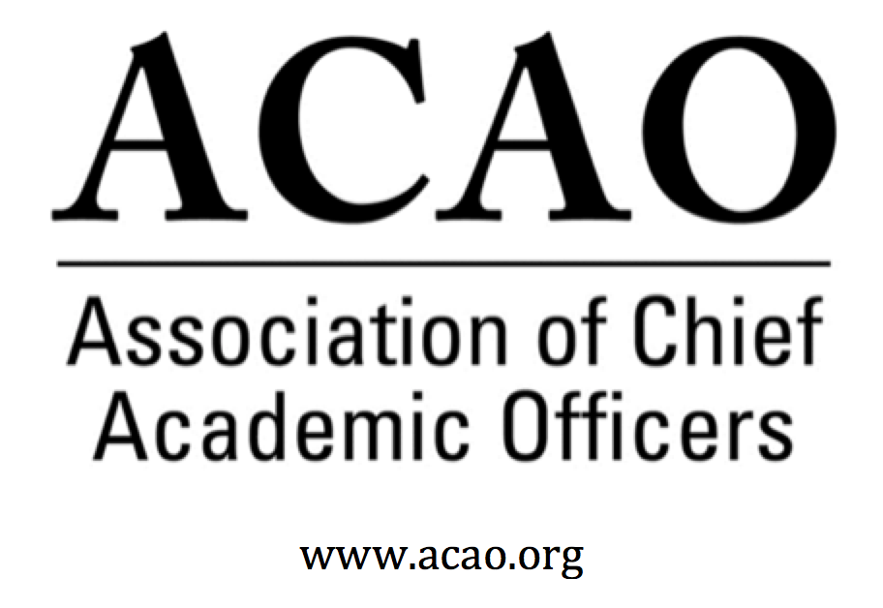

Minutes

January 25, 2019

ACE Headquarters, Washington, DC

Name | Attend | Name | Attend | Name | Attend
Martha Potvin | Yes | Laura de Abruna | Yes | Michaele Whelan | Yes
Kathy Johnson | Yes | Peter Nwosu | No
Mary Boyd | Yes | Gregory Ochoa | No
Rick Miranda | No | Patricia Rogers | Yes
Kevin Carman | Yes | Connie Johnson | No
Charles Cook | No | Todd Diacon | No | Doreen Murner | Yes
Kelli Brown | No | BJ Reed | Yes

*Since there was not a quorum present, no formal votes were taken. Below you will see RECOMMENDATIONS from the board members present.
- Dec 12 Board Minutes – Vote to approve – M. Potvin
  - Laura motion to approve 12/12 minutes. Mary 2nd. No discussion.
RECOMMENDATION to approve 12/12 minutes
- ACE/ACAO MOU: M. Potvin/K. Johnson
  - Topic of discussion was how to best leverage the joint relationship with ACAO content and access to the ACE platform.
  - Philip, Louis and Nicole from ACE had lunch with ACAO board and talked about potential opportunities. Engage is still in “beta” but they would like to present Engage to ACAO board at the 3/9th ACAO board meeting in Philadelphia.
  - Martha follow up with Philip Rogers; plans for March meeting – inclusion of ACAO in pilot of ACE Engage platform.

- Partnership Opportunities
  - ACE New Provost Institute – M. Potvin/K. Johnson
  - CCAS
  - AASCU
  - CIC

- Membership Committee Update – G. Ochoa All – contributing ideas for membership
  - Letter of Welcome from President to each new member
  - Aggregate lists of promotions in the Chronicle & Inside Higher Ed, then send the new provost a congratulations letter and recommend ACAO (new member would become a prospect and this might be where the Advisory Council can help out)
  - Is there a way to promote ACAO to Inside Higher Ed for quotes and/or credibility of their research?

- Communications Committee Update – C. Johnson K. Johnson. It was communicated to the group that there should be consideration to combine the Communications Committee with the Membership Committee, since most of the work of the Communications Cmte entails Membership. Discussion only.

- Bylaws Committee Update – R. Miranda – No Update

- Finance Committee Update - M. Boyd
Jan-Nov 2018 financials discussed. Membership is still key to addressing shortfall. Critical need for additional revenues and/or further expense reduction
  - ACAO is in a good cash position. Line item details discussed.

- Nominating Committee, 2018/2019 Slate presented – BJ Reed
  - Slate presented to the board: Andrew Shean; Carol Baker, Lori Werth, Michele Wheatly, Laura Woodworth. Ballots will be created with a web page for voting. Voting will close end of February.
  - RECOMMENDATION to accept slate of candidates presented for 2019 election.
  - There was discussion to provide roles and responsibilities and expectations to the newly elected board members. RECOMMENDATION to provide board expectations to candidates.

- Program Committee – K. Johnson
  - There will be two ACAO programs on the ACE program this March.

- Advisory Council Update – C. Johnson D. Murner
  - There is concern about continuity on the Council when Connie steps down in March. Who will be the Liaison to the Council? The board highly values the Council’s work and wants to ensure its continued value. Due to the importance of the Council, Kathy Johnson will step in as interim liaison as Connie transitions off.
  - Future idea for Council webinar/content: Working with search firms. Provosts going through unexpected job change. How to answer search firm questionnaire and explain about you last position when that happens. How to think about moving forward to the next opportunity.
  - Question about a Council name change. Since the Advisory Council isn’t really advising the board, should it have a new name with more value, recognition and importance? Senior Fellows was suggested as an alternative Council name. Also, to align with the name change should there be a Council rep on the ACAO board? And ex-officio of the board.
  - For membership, the Council offered to help in any way the board would like them to.
  - An option for non-dues revenue was discussed; charging a fee for the Council’s monthly Coffee Hr. webinars. Discussion only. Another option was asking Council members for donations in lieu of dues.
  - Should there be a membership category of “Sr Fellows” and they are automatically on the Council. This option would require more discussion.

- Digital Fellows Update & future grant opportunities – L. de Abruna
  - BMGF grant extended to continue regional convenings. Along with provosts, faculty and instructional designers are invited to these meetings. Board is encouraged to promote ACAO at the regional convenings. Also discussed all Digital Fellows should be ACAO members at this point.
  - Conversation on how to move Digital Fellows work forward? ACAO needs a partner to accomplish this. ACE? AAC&U? Educause? CIC? John Gardner Institute? Laura will look at various options and report back.

- March Board Meeting & ACAO Business Meeting agenda & planning – K. Johnson
ACAO Board of Directors Meeting
Date: Sat March 9, 2018
Time: 4-6pm (after Digital Fellows mtg)

ACAO Breakfast & Business Meeting
Date: Sun March 10, 2018
Time: 7:45 - 10:30am (7:45-8:15 Member Breakfast; 8:15-10:30 Business Mtg)

- Strategic Plan Completion – K. Johnson
  - Draft revised – RECOMMEND adopting strategic plan goals

- New Business
  - Google Group site for all ACAO documents in perpetuity
  - Listserv options via Google or member data base – this would be perceived as a member benefit

Future Board Meetings
Feb 6, 2019 2:00pm ET
Mar 6, 2019 2:00pm ET
March face to face @ ACE Annual Meeting, Philadelphia, PA

